Kevin Chen

Reflection: I learned how to implement JUnit testing for Book.java, but also other classes that I will need to use in the future. I also learned how to correctly format and write javadocs to comment how my code functions so I can return to it later and still remember what I was doing. I also learned how to structure my tests so that they will achieve a sufficient percentage of coverage. Above all else, I learned how to use the Eclipse IDE which includes a package manager and live compiler error reporter.

Screenshots: (Already in ICE)

Extensions:

I am using two object classes and a test class for each one of the object classes (Person & Book). I have also added a driver method for the Answer class (AnswerDriver.java) as a proof of concept.

Grading Statement:

Both my PersonTest and BookTest have 100% coverage, and I have also added comment blocks at the beginning of each class as well as generated JavaDocs in a consistent format across all files. I believe this my code is also formatted well and easy to go through. Regarding code quality, I saw the following warnings:  
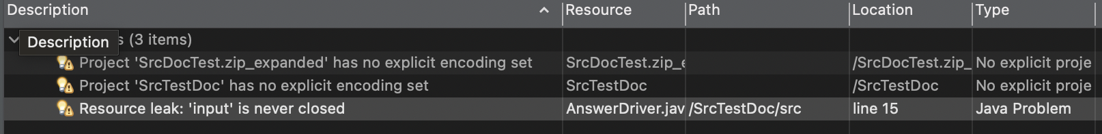

From my research, I believe the first two are an ongoing issue with Eclipse, and the third is not a resource leak as I’m opening from System.in, which is the standard input. Due to these warnings I wasn’t able to remove I think it’s fair to deduct 5 points. However, since I also curated the AnswerTest driver as suggested, so I believe that’s creative enough to satisfy the extra 10 points.